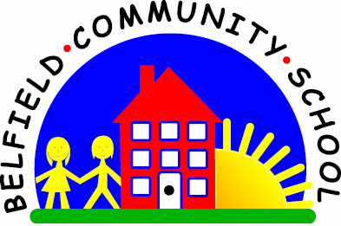
Metropolitan Borough of Rochdale
Education Committee

3.2 Using songs and rhymes to learn single words/the names of body parts

Why is this important?
The names of body parts are part of a child’s early vocabulary. At first children learn to understand the word on its own and then phrases using the word (e.g. ‘Mummy’s hand’, ‘Tommy’s eyes’).
----------------------------------------------------------------------------------------------------------------------
What to do
• Sing lots of action songs together relating to body parts. Examples include:
★ ‘Head, Shoulders, Knees and Toes.’
★ ‘Here We Go Round the Mulberry Bush’
(e.g. this is the way we ‘wash our teeth’, ‘brush our hair’).
★ ‘If You’re Happy and You Know It …’
• As you sing, point to each body part together.
• Encourage the child to join in with the actions
and point to body parts as you sing.
• Make up songs using well-known tunes
(e.g. ‘The Wheels on the Bus’ could be adapted to ‘Katie on the bus, she claps her hands’ or ‘The children on the bus they touch their toes’).
• During everyday routines (e.g. getting dressed, bath-time) ask the child to ‘Point to nose’, ‘Wash tummy’, ‘Put sock on foot’).
- Head, Shoulders, Knees & Toes
- Here We Go Round The Mulberry Bush
- If You're Happy & You Know It
- One Finger One Thumb
- This Little Piggy Went To Market

