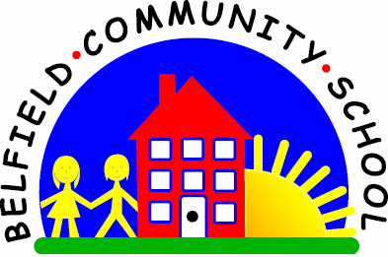
Metropolitan Borough of Rochdale
Education Committee

3.6 Putting two early words together

Why is this important?
As children are beginning to string words together, words such as ‘more’, ‘gone’ and ‘bye-bye’ can be added to the object names that the child has acquired. They are a fun and easy way to develop two-word phrases. These are often referred to as pivot phrases.
----------------------------------------------------------------------------------------------------------------------
What to do – ‘more’
• Choose high-interest items for this activity!
• Break a biscuit, apple, banana, piece of toast into small bite-size pieces and pass
the child a small piece to eat.
• When he/she reaches or vocalises for ‘more’,
say ‘more biscuit’ and pass over another piece.
• As this becomes consistent, encourage the child to ask for ‘more’. Pause as he/
she is reaching to give a chance for the word to be used.
• Remember – it doesn’t matter if the word isn’t perfect!
• When the child is using ‘more’,
encourage joining the ‘more’ with the item (e.g. ‘more apple’).
• Blow bubbles: encourage the child to say ‘more bubbles’ before you respond.
-----------------------------------------------------------------------------------------------------------------
What to do – ‘gone’
• Gather together a box or bag and some everyday objects/toys.
• Encourage the child to post the objects into the box/bag.
• As each one is posted, you say ‘gone’.
• Now pause after each object has been posted, waiting to see if the child will copy.
• When the child is consistently using ‘gone’, begin to join ‘object + gone’ as the
child posts the objects or puts them away in the bag
(e.g. ‘keys gone’, ‘brush gone’).

