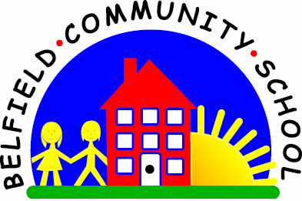
Metropolitan Borough of Rochdale
Education Committee

3.7 Using one word to describe an action

Why is this important?
Action words (verbs) describe what is happening/what someone or thing is doing. They are more abstract than object names (i.e. they can’t be seen) and therefore can be trickier to learn. Describing what someone else is doing is a further step along this road.
----------------------------------------------------------------------------------------------------------------------
What to do
• During movement or physical play, talk about what the child is doing.
Ask the child if he/she can copy, e.g.
★ ‘Mummy’s jumping. Can Amy jump?’
★ ‘That boy’s climbing. Can Jalil climb?’
• As the child begins to understand the action words, ask: ‘What is Amy doing?’
• Sing nursery rhymes that include actions, e.g.
★ ‘Here We Go Round the Mulberry Bush’
(e.g. ‘this is the way we clap our hands, stamp our feet, jump up and down’).
★ ‘The Wheels on the Bus’ (e.g. ‘the people/children on the bus, they wave bye-bye,
nod their head, eat their lunch’).
★ ‘If You’re Happy and You Know It …’
• Encourage the child to join in with the actions: sometimes pause and ask, e.g.
★ ‘What did we do with our hands?’ – ‘clap’.
• Play ‘Simon Says’. Ask the child to follow instructions to:
★ Jump, walk, run, sleep, clap, fall down, etc.
• At first, do the actions together and then let the child try by him/herself. Get doll
or teddy to play along too. Reverse the roles so the child has to tell others what to
do – you could use picture cards for this so one child, in turn, tells the others to do
the action on the card.
• Look at picture books together, talking about what people are doing. Ask, e.g.
★ ‘Find someone who’s running.’
• Take it in turns to find someone and say what is happening. If the child is unsure
of the right word, offer a choice ‘Is he running or sleeping?’
• During play, you describe what is happening and/or
ask the child what he/she’s doing, e.g.
★ In the home corner
brushing teeth/hair, eating, sleeping, sitting, cooking, tidying, cleaning.
★ During ball play – the child can roll, bounce, throw and catch.
★ Playing with cars – the child can push, crash, pull and stop.
★ Craft play – cutting, painting, cooking, drawing, colouring, etc.

Below are links to videos to help with the teaching of the above
Action Verbs YouTube link: https://www.youtube.com/watch?v=d8SbAkn3uvs
Action Words Talking Flashcards link: https://youtu.be/hzo9me2fdzg
Action Songs: Singing Walrus: https://youtu.be/dUXk8Nc5qQ8

