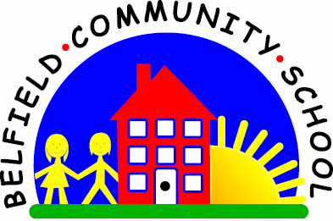
Metropolitan Borough of Rochdale
Education Committee

4.10 Learning to use ‘big’ and ‘little’

Why is this important?
‘Big’ and ‘little’ are important opposites. They form the building blocks of
more abstract concept development and give children a means to describe
the world around them. They are often amongst the earliest adjectives
(describing words) that children learn. Usually ‘big’ is learned before ‘little’.
-----------------------------------------------------------------------------------------------------------
What to do
• Gather together:
★ A selection of objects – one ‘big’ and one ‘little’ (e.g. ‘big’ cup and ‘little’ cup;
‘big’ pencil and ‘little’ pencil).
• Explain that you are going to take it in turns to tidy up and put the things away into a box/bag.
• Put out a pair of items (e.g. two cups, one ‘big’ and one ‘little’).
Tell the child to find the ‘big cup’. Put it in the box.
• Ask the child:
★ Adult: ‘What did you put in the box?’
★ Child: ‘Big (cup)’.
• Point to the remaining cup:
★ Adult: ‘What shall I put in the box?’
★ Child: ‘Little (cup)’.
• During outdoor play, ask the child to jump into a ‘big’/‘little’ hoop. ‘Step up’ by
asking: ‘Which hoop are you in?’
• There are numerous opportunities throughout the day for teaching ‘big’ and ‘little’ – laying the table (‘big’ spoon, ‘little’ spoon), matching shoes etc.

