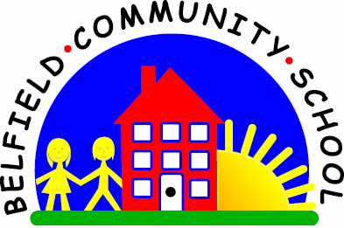
Metropolitan Borough of Rochdale
Education Committee

5.5 Learning the meaning of ‘where’
Why is this important?
Wh- questions are an integral part of everyday conversations and routines
(e.g. ‘Where’s your coat?’). Children need to be able to follow these
instructions to be able to respond appropriately to questions and to move
from a concrete to a more abstract level.
-----------------------------------------------------------------------------------------------------------
What to do
• Gather together some toys or objects and place them around the room.
• Encourage the child to find one item at a time by asking: ‘Where’s the …?’
• If the child can manage this, move on to the next item.
• If the child responds incorrectly (e.g. by naming the item retrieved rather than
where it is), repeat the question and give the answer, e.g.
★ Adult: ‘Where’s the ball?’
★ Child: ‘Ball.’
★ Adult: ‘Where’s the ball? On the table.’
• You could also try repeating the question and then start to
model a response for the child to complete, e.g.
★ Adult: ‘Where’s the ball? The ball’s on the …?’

Link to ‘Where’s the Monkey? YouTube Clip
https://youtu.be/idJYhjGyWTU

