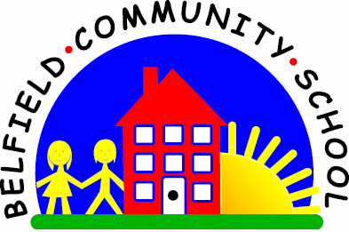
Metropolitan Borough of Rochdale
Education Committee

6.10 Learning to remember and then say the
names of three things
Why is this important?
Verbal understanding can be likened to a ‘list’ of things that need to be
remembered in order to carry out a task. If, for example, a three-word
instruction is given (e.g. ‘Wash doll’s face’), the child has to remember
‘wash’, ‘doll’ and ‘face’. If he/she can’t do this, it may be that auditory
memory is not yet sufficiently developed.
----------------------------------------------------------------------------------------------------------
What to do
• Gather together a selection of pictures of everyday things.
These could be cards or cut out from magazines.
• Place a few cards (i.e. four) face-down on the table.
• Choose three cards but don’t show them to the child.
• Look at the cards and say what they
are (e.g. ‘I’ve got a hat, a cup and a pencil’). Ask:
★ ‘Can you remember what cards I’ve got?’
• If the child is right, show your cards and reinforce:
★ ‘Well done! A hat, a cup and a pencil!’
• If the child finds it difficult or remembers only one or two items,
repeat what cards you have, emphasising the key words
(e.g. ‘I’ve got hat, cup and pencil’).
• Try the activity with some action pictures (e.g. ‘doll is sitting’, ‘boy
jumping bed’). Can the child copy these three-word phrases?

