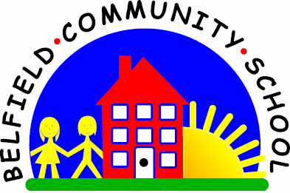
Metropolitan Borough of Rochdale
Education Committee

8.8 Understanding question words using stories
Why is this important?
Children need to be able to process a variety of question words in a range of
different situations. Questions are a way of finding out what children
know/can remember about an activity/event, etc. and also a means of
encouraging reflection and thinking skills.
-----------------------------------------------------------------------------------------------------------
What to do
• Read a simple story together. Choose favourite books, about animals
perhaps, or favourite characters
(e.g. ‘Harry and the Bucketful of Dinosaurs’).*
• Ask questions about the story (e.g. for ‘Snow White and the Seven Dwarves’,
ask:
★ ‘Where did the dwarves go to work?’
★ ‘What were the dwarves digging for?’
★ ‘Why did Snow White go to sleep?’
★ ‘Who gave Snow White the
poisonous apple?’
★ ‘How did the dwarves feel when Snow White went to sleep?’)
• If the child doesn’t answer or answers inappropriately, try:
★ Offering a choice of answers (e.g. ‘Where did the dwarves go to work?
Was it in a shop or down the mine?’).
★ Re-read part of the story where the answer is and then repeat the question.

