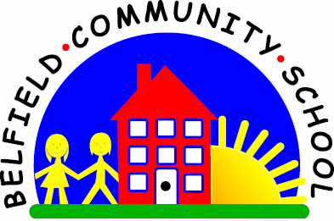
Metropolitan Borough of Rochdale
Education Committee

9.5 Predicting what might happen next
Why is this important?
Children need to learn to predict in order to problem-solve and decide what,
in all probability, is going to happen next. This involves analysing and
synthesising information.
----------------------------------------------------------------------------------------------------------
What to do
• Read a story together. This might be a fairy story, a book from the library,
school reading book or story in a child’s magazine.
• Read a few pages to introduce the characters.
• At key places, stop and before you turn the page, ask: ‘What do you think
might happen next?’
• The child may need more guidance and more direct questions (e.g. when
reading ‘Goldilocks and the Three Bears’, you could ask ‘Whose house
do you think she will find?’ After she’s eaten the porridge, ask ‘What’s
Goldilocks going to do now?’ and when the bears come home, ask ‘What do
you think the bears are going to find?’).
• In the ‘Oxford Reading Tree*’ stories, there is often something ‘funny’ that
happens on the last page. Stop before this page to ask the child what he/she
thinks might happen at the end.

