



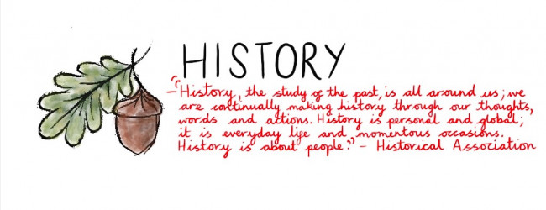

**History Annual Curriculum Map**

**Belfield Community School**

**History Annual Curriculum Map**

|  |  |  |  |  |  |  |  |  |
| --- | --- | --- | --- | --- | --- | --- | --- | --- |
| **History Curriculum Map - Autumn Term** | | | | | | | | |
| **Term** | **Nursery** | **Reception** | **Year 1** | **Year 2** | **Year 3** | **Year 4** | **Year 5** | **Year 6** |
| **Autumn 1** | **Recent History-Photograph Books**  **Recent history, new brothers / sisters / growing up** | **My past, present and future**  **My family** |  |  | Changes in Britain from Stone Age to Iron Age  Stone Age  Bronze Age  Iron Age/Celts | Achievements of the earliest civilisations  Ancient Egypt | Britain’s Settlements by Anglo-Saxons and Scots  Anglo-Saxons  Scots | A local historical study  ‘The Rise of Rochdale’ (Victorians) |
| **Autumn 2** | **Guy Fawkes**  **Remembrance Day** |  | Lives of significant people in the past  Henry VIII/Tudors | Vikings and Anglo-Saxons struggle for the kingdom of England  Vikings |
| **History Curriculum Map - Spring Term** | | | | | | | | |
| **Spring 1** | **Family Members visiting nursery**  **Talking about members of our family** | **Kings and Queens – past and present** | Lives of significant people  Mary Anning |  | The Roman Empire and its impact on Britain  Celts  Romans |  |  | An aspect of British history beyond 1066  WW2 |
| **Spring 2** | **Transport – Past and Present – Amelia Earhart** |  | Significant historical events in own locality  The Co-operative |  |  |
| **History Curriculum Map - Summer Term** | | | | | | | | |
| **Summer 1** | **Celebrations – Eid, Fathers’ Day,**  **Focus on our nursery journey.**  **Recent history, photograph books** | **Pre-history**  **Dinosaurs** | Events from beyond living memory  Great Fire of London | Events from beyond living memory  Titanic |  | Ancient Greece – Life, achievements and influence  Ancient Greece | Non-European society that contrasts with British History  Early Islamic Civilisations (Baghdad) |  |
| **Summer 2** |  | Changes within living memory  Toys then and now |  |  |  |