



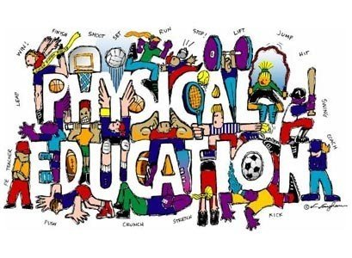

**Physical Education Annual Curriculum Map**

**Belfield Community School**

**Physical Education Annual Curriculum Map**

|  |  |  |  |  |  |  |  |  |
| --- | --- | --- | --- | --- | --- | --- | --- | --- |
| **PE Curriculum Map - Autumn Term** | | | | | | | | |
| **Term** | **Nursery** | **Reception** | **Year 1** | **Year 2** | **Year 3** | **Year 4** | **Year 5** | **Year 6** |
| **Autumn 1** | People Who Help Us | People Who Help Us | Multi-Skills | Multi-Skills | Hi-5 Netball | Hi-5 Netball | Hi-5 Netball | Hi-5 Netball |
| **Autumn 2** | Autumn /  Celebrations | Autumn /  Celebrations | Gym | Gym | Gym | Gym | Gym | Gym |
| **PE Curriculum Map - Spring Term** | | | | | | | | |
| **Spring 1** | Winter | Winter | Dance | Health Related Exercise | Dance | Health Related Exercise | Dance | Health Related Exercise |
| **Spring 2** | Transport | Transport | Health Related Exercise | Dance | Health Related Exercise | Dance | Health Related Exercise | Dance |
| **PE Curriculum Map - Summer Term** | | | | | | | | |
| **Summer 1** | Dinosaurs | Dinosaurs | Striking and Fielding | Athletics | Rounders | Athletics | Rounders | Athletics |
| **Summer 2** | Growing /  On the Farm | Growing /  On the Farm | Athletics | Striking and Fielding | Athletics | Rounders | Athletics | Rounders |