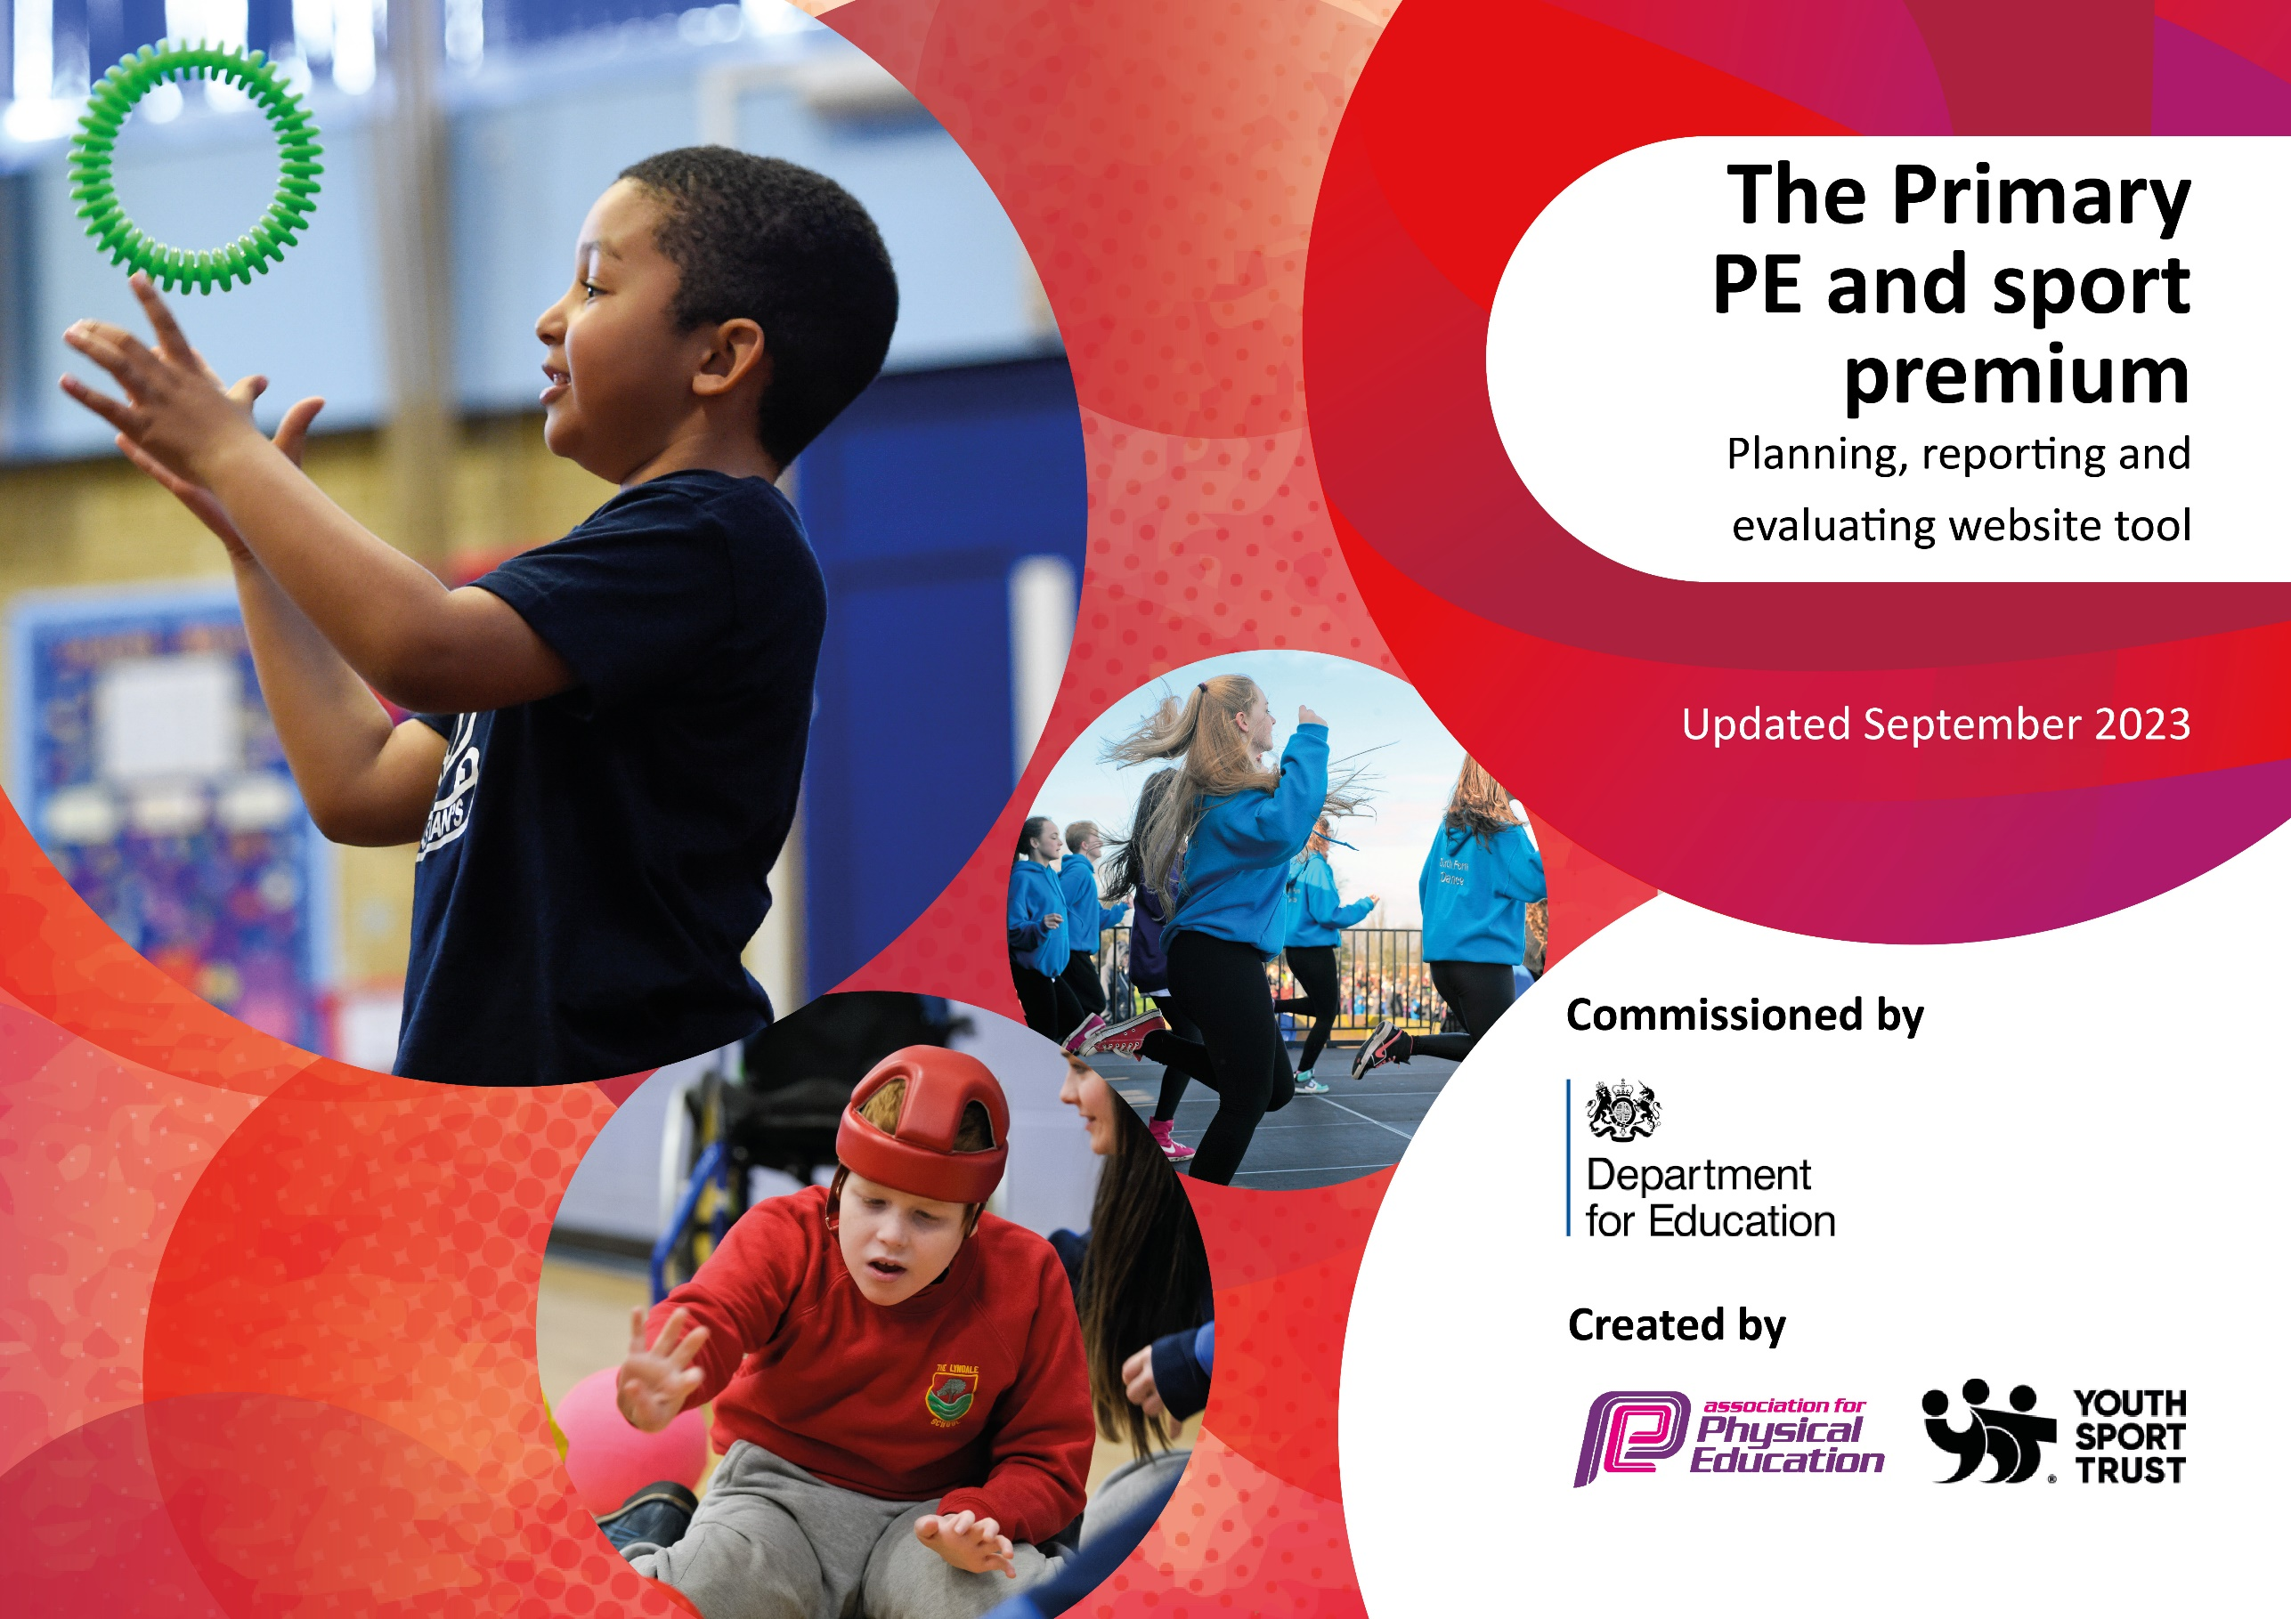

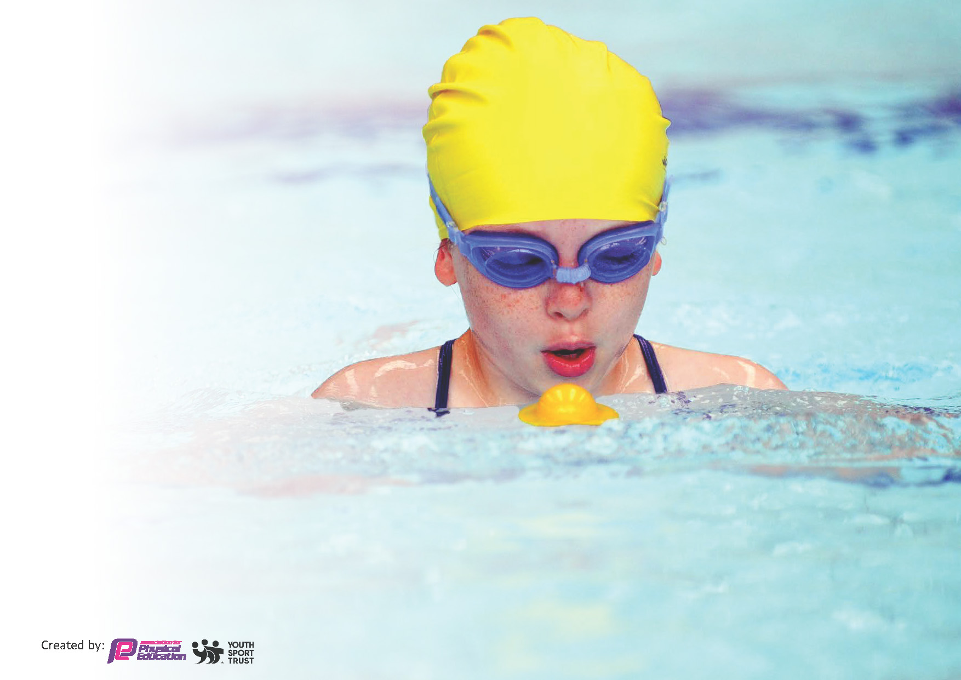
This template can be used for multiple purposes:
by:
- It enables schools to effectively plan their use of the Primary PE and sport premium
- It helps schools to meet the requirements (as set out in guidance) to publish information on their Primary PE and sport premium
- It will be an effective document to support Ofsted inspections enabling schools to evidence progress in Physical Education (PE) and evidence swimming attainment, which forms part of the PE National Curriculum. We would recommend schools consider
the Intent, Implementation and Impact of any spend, as examined within the Education Inspection Framework.

It is important that your grant is used effectively and based on school need.

Schools must use the funding to make additional and sustainable
improvements to the quality of the PE, School Sport and Physical Activity (PESSPA)
they offer. This means that you should use the Primary PE and sport premium to:

- Build capacity and capability within the school to ensure that improvements made now will benefit pupils joining the school in future years
- Develop or add to the PESSPA activities that your school already offers.

The Primary PE and sport premium should not be used to fund capital spend projects; the school’s core budget should fund these. Further detail on capital expenditure can be found in the updated Primary PE and sport premium guidance.

The Primary PE and sport premium guidance, outlines 5 key priorities that funding should be used towards. It is not

necessary that spending has to meet all the key priorities, you should select the priorities that you aim to use any funding towards.

Although completing this template is not a requirement for schools, schools are required to publish details of how they spend this funding. Schools must also outline what the impact this funding has had on pupils’ PE and sport participation and attainment and how any spending will be sustainable in the future. All funding must be spent by 31st July 2024.

The Department for Education has worked closely with the Association for Physical Education (afPE) and the Youth Sport Trust (YST) to develop this template and encourages schools to use it. This template is an effective way of meeting the reporting requirements of the Primary PE and sport premium.
Review of last year’s spend and key achievements (2022/2023)

We recommend you start by reflecting on the impact of current provision and reviewing your previous spend.

Activity/Action | Impact | Comments
2 hours dedicated “Active Time” in weekly timetable  Subject leader development  Introduction of new PE curriculum  Wide range of Physical Education activities outside of PE lessons – clubs, Sports Days, competitions and tournaments (Collaborative and wider borough competitions)  Yearly participation in Cycling activities and inter-school cycling competitions  Increased participation in lunchtime sporting activities led by sports coaches  Y6 Residential – activity weekend  Staff Connect Collaborative sporting competitions | Children fitter and healthier. Classes planning active time outside of the PE timetable  Subject leader understands their subject and the intent of the curriculum. Monitors closely the impact of the new PE curriculum and ensures consistent implementation.  Children given access to a wider range of sporting opportunities to create healthy habits. Traditional sports days ensured inclusion for all physical abilities. Individual children identified previously unrealized skills and talents.  Children developed road safety skills and ability to ride a bike confidently and proficiently  Children better engaged in sporting activities, developing social skills and healthier habits  Confidence building, independence building and character building. Experiencing opportunities otherwise wouldn’t access  Staff modelling healthy habits to children and being healthy role-models. Staff wellbeing increased. | Boot camp, rugby, lacrosse, football, multi-skills, dodge ball, netball, basketball, archery, cycling.  Achievements recognized in school  Netball and rounders competitions within collaborative – shared with children and celebrated.

Key priorities and Planning
This planning template will allow schools to accurately plan their spending.

Action – what are you planning to do | Who does this action impact? | Key indicator to meet | Impacts and how sustainability will be achieved? | Cost linked to the action
Continue to sustain a  Comprehensive PE & sport agenda and promote an active  Curriculum  Continue to develop our work with Ed Start  to enhance provision, particularly at lunchtime  Participate in a range of competitive sport events  Embed “The Power of PE” curriculum ensuring it  supports EYFS developing Curriculum and has consistent implementation  To provide opportunities for additional swimming sessions for SEND children from Year 4  To continue to fund additional adults at swimming lessons to improve number of children reaching expected standard, including transport to ensure the most is made of the time spent swimming | Pupils, teachers and staff  Pupils, staff CPD, Lunchtime organisers  Pupils  Subject Lead, Pupils, Staff teaching PE  Pupils and families of pupils with SEND  Pupils, particularly those with SEND or medical needs, Tas and Ts | Key Indicator 1: The engagement of all pupils in regular physical activity – Chief Medical Officers guidelines recommend that primary school pupils undertake at least 30 minutes of physical activity a day in school  Key Indicator 4: Broader experience of a range of sports and activities offered to all pupils  Key Indicator 3: Increased confidence, knowledge and skills of all staff in teaching PE and sport  Key Indicator 4: Broader experience of a range of sports and activities offered to all pupils  Key indicator 5: Increased participation in competitive sport.  Key Indicator 2: The profile of PESSPA being raised across the school as a tool for whole school improvement  Key Indicator 4: Broader experience of a range of sports and activities offered to all pupils  Key Indicator 1: The engagement of all pupils in regular physical activity – Chief Medical Officers guidelines recommend that primary school pupils undertake at least 30 minutes of physical activity a day in school  Key Indicator 3: Increased confidence, knowledge and skills of all staff in teaching PE and sport  Key Indicator 4: Broader experience of a range of sports and activities offered to all pupils | More pupils meeting their daily physical activity goal, more pupils encouraged to take part in PE and Sport Activities.  More pupils engaged in physical activity throughout the school day, not just in PE sessions. Chn more engaged in the afternoon lessons. LTOs skilled up to deliver  Pupils discover skills and talents in sports that otherwise they would not experience. Pupils begin to access clubs outside of school.  Pupils receive a high-quality PE curriculum, with clear progression to build on knowledge and skills as they move through school. Teachers become more skilled and confident.  Pupils with SEND succeed in learning to swim over a longer period of time. Parents feel more confident in continuing lessons outside of school.  All pupils will be supported adequately during swimming lessons and therefore become more proficient swimmers. Children will be confident in taking up swimming outside of school and therefore be safe and healthier. | £18,268  Lacrosse - £280  £500  Coaches - £2584

Key achievements 2023-2024
This template will be completed at the end of the academic year and will showcase the key achievements schools have made with their Primary PE and sport premium spending.

Activity/Action | Impact | Comments

Swimming Data
Meeting National Curriculum requirements for swimming and water safety.
Priority should always be given to ensuring that pupils can perform safe self-rescue even if they do not fully meet the first two requirements of the National Curriculum programme of study

Question | Stats: | Further context  Relative to local challenges
What percentage of your current Year 6 cohort can swim competently, confidently and proficiently over a distance of at least 25 metres? | 75% | Use this text box to give further context behind the percentage.  e.g., 30% - we are struggling to get pool space due to our local pool closing so we have had to use a much smaller local school pool. We have had to limit the number of pupils attending swimming lessons during one term which means some pupils have attended fewer swimming lessons than others.
What percentage of your current Year 6 cohort can use a range of strokes effectively [for example, front crawl, backstroke, and breaststroke]? | 75% | Use this text box to give further context behind the percentage.  e.g., Even though your pupils may swim in another year please report on their attainment on leaving primary school at the end of the summer term 2024

What percentage of your current Year 6 cohort are able to perform safe self-rescue in different water-based situations? | 75%
If your schools swimming data is below national expectation, you can choose to use the Primary PE and sport premium to provide additional top-up sessions for those pupils that did not meet National Curriculum  requirements after the completion of core lessons. Have you done this? | No | Instead, school used 2 TAs to support the swimming teaching. They support in  the water to enable more focused teaching cost to school £500
Have you provided CPD to improve the knowledge and confidence of staff to be able to teach swimming and water safety? | Yes | New member of Y4 staff undertook swimming training in order to best support a child with EHCP in the water.

Signed off by:

Head Teacher: | Carly Wilson
Subject Leader or the individual responsible for the Primary PE and sport premium: | Christopher Gibson
Governor: | Rachael El Weshahi
Date: | Sept 23

