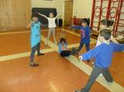





NEWSLETTER SUMMER 2018

Dear Parents/Carers

We have come to the end of another very busy year.
Children across all key stages continue to make progress and develop a true love of learning. We wish our wonderful Year 6 all the best at High School. They have worked really hard. Produced a wonderful performance, Matilda and entertained us with a musical concert with strings and cornets.

We say goodbye and thank you to Mrs Tinker who has spent over 20 years with us, we all have many memories of her time at Belfield, we wish her all the best in her retirement. Mrs Craven also retired last month and we send our very best wishes to her. Mrs Howarth is also moving on to a new School and we wish her every success. We also wish Mr Bowman all the best on his new adventures, Good Luck to Miss Bocock who is taking up a new position for 12 months and also to Miss Bosher who has taken maternity leave to have a baby.

Thank you for all your support in making Belfield a truly great school.

Please remember to look on our NEW web site where you can find lots of ways to help your children. Please make sure over the holidays your children continue to read and practise their tables, it really helps them. A big thanks to all mums and dads & carers for all you do to support the children. Can I ask you one more favour, keep reminding the children of our Behaviour for Learning rules:-
- Be a proud & successful learner
- Be kind and considerate
- Be safe and aware
These will also help you to keep your child happy & safe at home.
HELP THE CHILDREN LEARN THEIR TIMES TABLES & READ EVERYDAY THANKYOU
Have a lovely break and see you on the 5th September.

Mrs Farrell
Head Teacher

TERM DATES FOR 2018/2019 –
SUMMER 2018 WED 6 SEPTEMBER 2018
AUTUMN HALF-TERM FRID 19 OCTOBER 2018 MONDAY 29 OCTOBER 2018
CHRISTMAS 2018 FRID 21 DECEMBER 2018 MONDAY 7 JANUARY 2019
SPRING HALF-TERM FRID 15 FEBRUARY 2019 MONDAY 25 FEBRUARY 2019
EASTER 2019 FRID 5 APRIL 2019 TUESDAY 23 APRIL 2019
MAY DAY FRID 3 MAY 2019 TUESDAY 7 MAY 2019
SUMMER HALF-TERM FRID 24 MAY 2019 MONDAY 3 JUNE 2019
TEACHER TRAIN DAY FRID 5 JULY 2019 MONDAY 8 JULY 2019
SUMMER 2019 FRID 19 JULY 2019

Thank you to all parents and carers who have supported us this year with all our events. Without your involvement, Friends of Belfield would not be able to move forward. Thank you for your support.

Have you got any free time? Would you like to be involved with “The Friends of Belfield”?
Our FOB is about much more than simply fundraising. The FOB exists to provide closer links between home and school and it is an excellent way to bring staff, parents and friends together socially in support of the school, working towards a common goal. It is fun too – just ask any of the Committee members or FOB helpers. Obviously, as in any organisation, we have experienced some challenges but with the continued support of parents and staff, our FOB has always succeeded in its efforts.
Achieving More Together
Friends of Belfield

If you would like to get involved, either speak to your
child’s class teacher or call in at the school office for
more details. We need new members. Please do get
in touch.

NEWS  SPORTS DAY  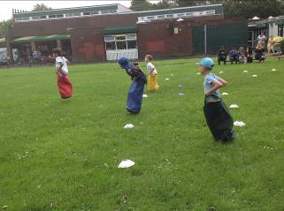  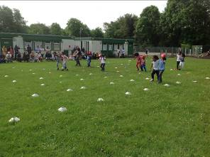  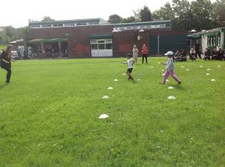  A great day was had by all. We had lovely weather and super support from the parents. All the children tried their best and had an  enjoyable time. | 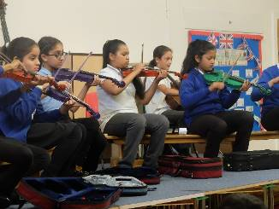    MUSIC TUITION  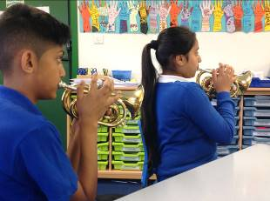  Teachers from Rochdale Music Service have been coming into school to provide a whole class project for Year 6 children who have been learning to play either a brass or string instrument. All the children have thoroughly enjoyed learning something new and they even performed a musical extravaganza for parents to show off their talents. Well done!!

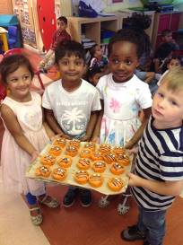
NURSERY
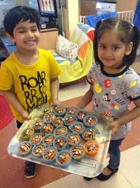
The Nursery children have had an amazing end to their year. We had a very successful trip to Richmond Hall soft play, the children had lots of fun using their physical skills to climb, jump and balance. Thank you to everyone who came on the day.
Back in Nursery we have been thinking about ‘The Jungle’. We have learnt the animal names, found out what different animals look like and discovered more facts about wild animals by reading information books. Everybody enjoyed baking a tiger bun and used their fine motor skills to create tiger stripes. We have enjoyed being outside in the sunshine, hunting for minibeasts, watering and caring for the plants and keeping cool reading books in the shade with our friends.
The children have worked really hard to write their names this term, please keep practicing this skill and continue to read and count with your child over the Summer holiday so they can amaze their Reception teachers in September! Have a happy and safe holiday.
Thank you for your continued support.
Nursery Staff


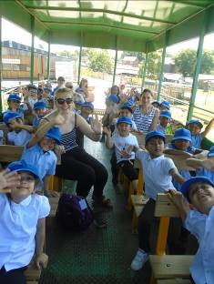
CLASS 1 & 2
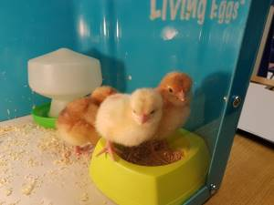
Reception have been busy as always this term. We hatched some chicks from eggs and nurtured them until they were ready to go to their new homes. Some of the staff and parents took them home and have kept us updated with lots of photos showing their progress. We enjoyed our trip to the farm very much, especially the bumpy tractor ride! The transition day to year 1 was exciting for all of the children and they are looking forward to start their new classes in September. The staff in foundation stage would like to say thank you to the children for all of their hard work this year, you have been amazing! Good luck in Year One.

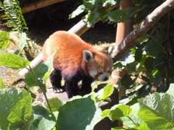
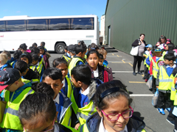
CLASSES 3, 4, 5 & 6
Year 1 & 2 enjoyed their trip to Blackpool Zoo. We saw lots of animals and had to fight off the pesky seagulls who tried to steal our lunch! We had a wonderful day and the children thoroughly enjoyed themselves.
The staff thank all parents for their support this year. Don’t forget to read lots of books during the holidays.

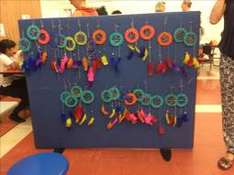
CLASS 7,8,9 & 10
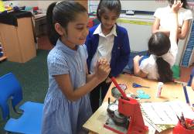
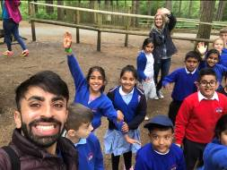
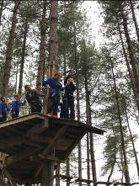
In the Summer Term classes 7,8,9 & 10 were ‘Have a Go Heroes’ on the high ropes during their trips to Go Ape. They also enjoyed learning about Maths through football in sessions that were provided by Soccer Academy. Just before transition day, all the children wrote to their new teacher to tell them about themselves and ask a few important questions!
For Enterprise Week we decided on a mindfulness & wellbeing theme where the children made keyrings and dream catchers. We have some young entrepreneurs amongst our children. Well done to all the children.

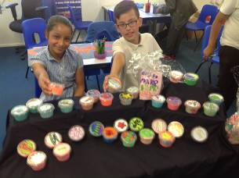
CLASS 11 & 12
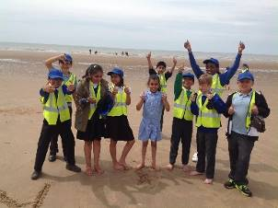
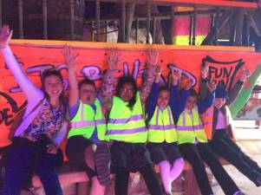
This term classes 11 and 12 have learnt about the book ‘Flotsam’ which discovers new underwater sea creatures and species. Both classes travelled to Blackpool Sea Life Centre for their school trip, to develop their knowledge of the underwater world. They also enjoyed playing Crazy Golf and spending time on the beach – hoping not to get their sandwiches stolen by seagulls! Year 5 have shown their Entrepreneurial skills by selling slime on Enterprise day making a grand total of £303.98 – fantastic work! We hope the children have a brilliant summer holiday and enjoy their time off, before coming back to Belfield in September, ready
for Year 6.

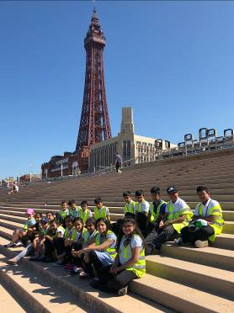
CLASS 13 & 14
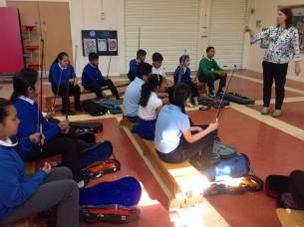
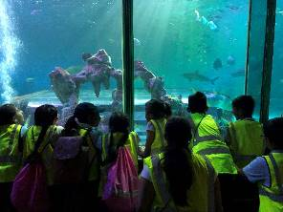
This term Year 6 have been very busy! We have continued to learn about Ancient Greece and have created Greek vases out of paper mache. We have also participated in sports day, where the children competed in a number of races and the children have visited their high schools in preparation for next year. Alongside this we have been preparing for our end of year performance, as well as participating in string and brass instrument lessons. Last week, we went on our end of year trip to Blackpool, where we visited the Sealife Centre, played a round of crazy golf and explored the beach. We look forward to seeing you at our end of year performance and celebration evening where we can share your children’s achievements from this year.

FREE SCHOOL MEALS

As you may be aware all children in reception, year 1 and year 2 who currently pay for school dinners or bring a packed lunch from home are entitled to a Universal Infant Free School Meal (UIFSM), irrespective of income and family circumstances.
However, if you think you may be entitled to Free School Meals if you or your partner is receiving benefits, please call into the school office to fill in a form. If your circumstances change in the future and you then receive benefits, you will need to apply for free school meals (FSM) in the usual way as the new arrangements do not take this into account.
The cost of a school dinner is still £10.50 per week (£2.10 per day) for all other children in Key Stage Two. All dinner money must be paid on Monday morning and if we receive no dinner money after two weeks your child will require a packed lunch or be sent home for dinners. Your debt will then be sent onto a debt collecting agency for payment and further costs could be accrued. Thank you.

TEXT SERVICE

We will be reminding parents of our up and coming events etc by text so please make sure the office has your recent mobile number. If you are not registered with school for the texting service, please call into the school office and give your details. We also have the facility to now e-mail parents so if you have an e-mail address please provide this. It is extremely important that school can notify you by text or e-mail, not only for events but in case of an emergency. Many thanks.

PARKING
Please be aware that parking outside school is putting the lives of our children at risk. Please DO NOT park on the yellow zig zag lines or opposite. The school grounds are for the use of staff only and should NOT be used for parents dropping off and collecting their children from school. Please be aware that staff do need to leave the school premises for meetings, training etc and blocking in/double parking can cause untold complications. The safety of our children is of the upmost importance so please put the children first and park safely away from school. Thank you.


EXTENDED LEAVE
Recently there have been a number of parents taking their children out of school during term time to go on extended leave. As you are probably aware, in order to improve school attendance, the Head teachers and governors do not grant leave of absence during term time. If you do need to take your child out of school you will need an appointment with Mrs Farrell, so please contact the school office. Please consider your child’s education before taking them out of school. Thank you for your continued support.


ATTENDANCE & PUNCTUALITY
A huge thank you to all parents who are sending their children into school on time. If your child is absent from school please remember it is your duty to contact school and let us know the reason before 9.00am on the day.

Children are required to attend school for 190 days. If your child has an attendance of 95% this is equal to 9 days absent, approx. 2 weeks absent and 50 lessons missed!!
A reminder that all late children must be signed in at the school office in the morning, and also at home time. Thank you.

There has been a sharp rise in the number of families taking children out of school for appointments. Please make dentist and doctors’ appointments after school or during the school holidays. Thank you.


School will close for the Summer Holidays on Friday 20th July, children can be collected from 1.15pm and we will re-open on Wednesday 5th September 2018 at 8.45am.
HAPPY HOLIDAYS TO YOU ALL

